Resources: Folder
A folder resource is useful if you need your learners to access many files. You can also create a sub-folder. If you delete a Folder resource, all the files associated with this resource will be permanently deleted.

Contents
- Add a Folder Resource
- Delete a Folder Resource
- Notes

Add a Folder Resource
There are three ways you can upload a folder. Please make sure that your folder has been zipped.
1) Drag and drop a folder into the course page.
a. Go to the course home page.
b. Drag and drop a zip file into the course section.
c. Choose Unzip files and create folder.
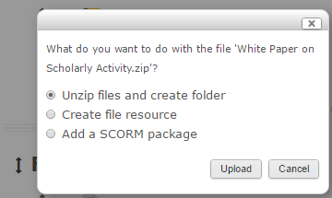

2) Using Add an activity or resource.
a. Go to the course home page.
b. Click on the Turn editing on button at the top right of the page.
c. Click Add an activity or resource.
d. Click the radio button next to the Folder and click on the Add button.
The Adding a new Folder page will appear.
e. Enter a Name and Description (optional).
f. Drag and drop a zip file or a file in the content box.
g. Repeat, if you want to add more files to the folder.
h. Click on the Save and return to course or Save and display button.
3) Using a file picker.

a. Upload a folder from Add an activity or resource. (See a-e above)
b. The File picker window will appear. Select Upload a File.
c. Click on Upload a File and the Choose File button.
d. Navigate to the file you want to upload, and click Open.
e. Click on the Upload this file button.
f. Repeat steps a - e, if you want to add more files to the folder.
g. Click on the Save and return to course or Save and display button.

Delete a Folder Resource
- Go to the course home page.
- Click on the Turn editing on button.
- Click Edit next to the Folder resource.
- Click Delete.

Notes
For additional information, see the Working with Folders Moodle Docs or contact Moodle Help.

